***Experiment 4***

**Aim:** SQL Queries with Hive: Write and execute SQL queries using Apache Hive to analyze structured data stored in HDFS, and perform operations such as filtering, joining, and aggregating data.

***Hive Commands and Output:***

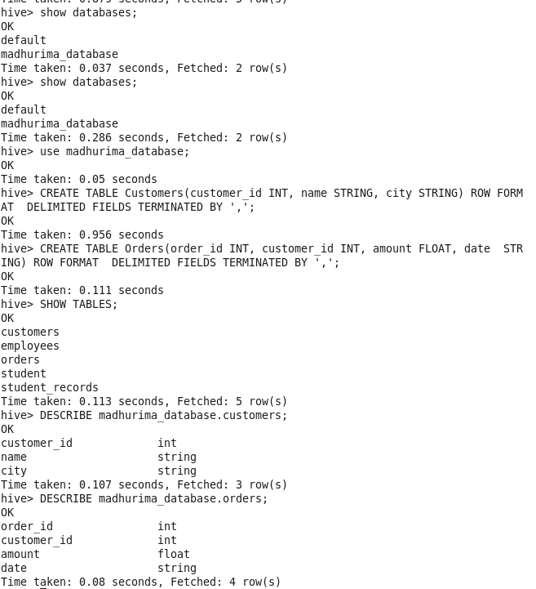

***Fig 1: Database Commands and Table Creation***

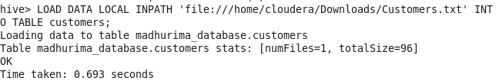

***Fig 2: Loading Data in Customer Table***

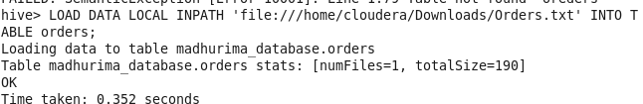

***Fig 2: Loading Data in Orders Table***

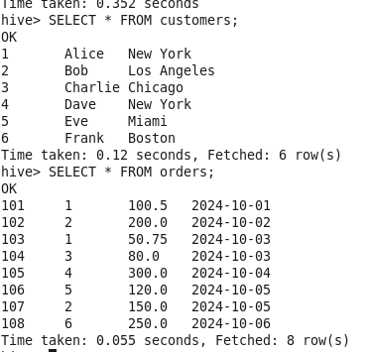

***Fig 3: Displaying Created Tables***

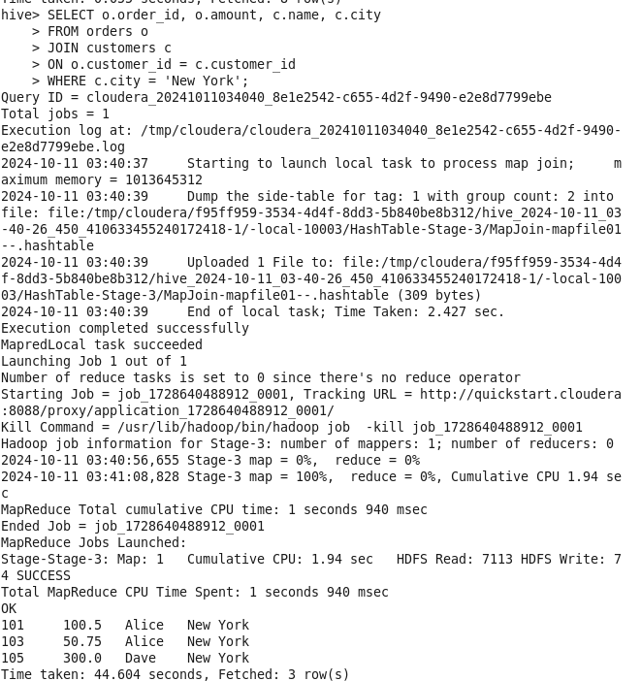

***Fig 4: Join Operation on Tables Customers and Orders***

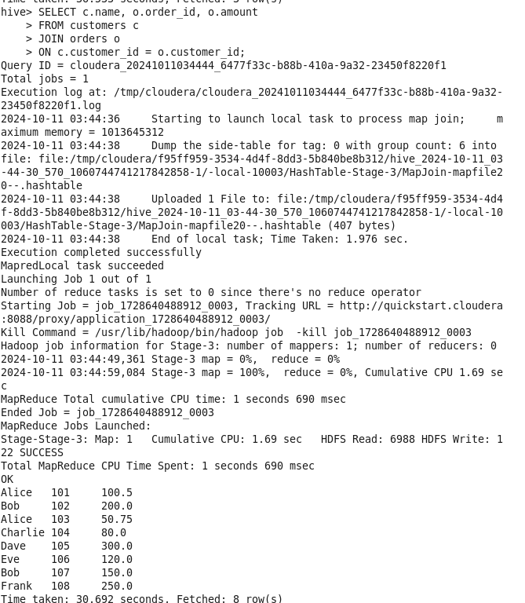

***Fig 5: Join Operation on Tables Customers and Orders***

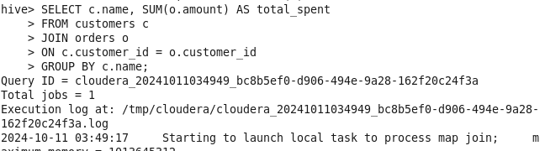

***Fig 6: Aggregation Operation on Tables Customers and Orders***

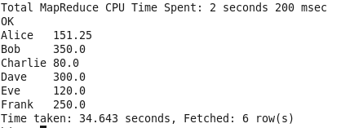

***Fig 7: Aggregation Operation Output***